**AVAILABILITY ANALYSIS OF STEAM BOILER**

A Final Report Presented to

Dr. Younes Shabany

San Jose State University

In Partial fulfilment

Of the Course Requirement for ME 210, Spring 2019

Department of Mechanical Engineering

By

Christabelle Peter

April 10, 2019

**Case Problem**

A steam boiler may be thought of as a heat exchanger. The combustion gases may be modelled as a stream of air because their thermodynamic properties are close to those of air. Using this model, consider a boiler that is to convert subcooled liquid water at 3.5 MPa and 150 degree Celsius to a superheated vapor at 400 degree Celsius while maintaining the water pressure constant. Combustion gases enter the boiler at 200kPa pressure.

Determine the temperature at which the combustion gases must enter this boiler so that the transfer of exergy from the combustion gases to the boiling water is done at minimum exergy loss per mass flow rate of water for the following two cases:

1) The combustion gases leave the boiler at the same pressure as they entered, i.e. 200 kPa.

2) The combustion gases leave the boiler at atmospheric pressure of 100 kPa.

**Schematic Diagram and Given Data:**

2

1

Superheated vapor

P = 3.5MPa

T = 400 °C

Subcooled liquid

P = 3.5MPa

T = 150 °C

Water

3

4

P gas  = 200 kPa

P gas

Combustion gas

Figure 1

**Assumptions:**

1. Control volume shown in the figure operates at steady state
2. Kinetic and potential energy effects can be ignored
3. Combustion gases are modelled as air as an ideal gas
4. Boundary of the system is adiabatic
5. P0 = 100 kPa
6. Irreversible

**Analysis:**

First evaluate the mass flow rate of combustion gas in terms of mass flow rate of the water. The combustion gas and water pass through the steam boiler in separate streams. Thus, at steady state the conservation of mass are shown below:

For air: $\dot{m_{3}}= \dot{m_{4}}$

For water: $\dot{m_{1}}= \dot{m_{2}}$

Using energy rate balance for the control volume at steady state and it reduces to:

Equation 1

$$0= \dot{Q_{cv}}- \dot{W_{cv}}+ \dot{m_{a}}\left( h_{3}- h_{4}\right)+ \dot{m_{w}}\left( h_{1}- h_{2}\right)$$

Equation 2

$$\dot{\frac{m_{a}}{\dot{m_{w}}}}= - \frac{\left( h_{1}- h_{2}\right)}{\left( h_{3}- h_{4}\right)}$$

Saving this equation later for calculation, now let us look at the entropy balance equation as shown below. There is no heat or work going through the system boundary thus it gives the equation below.

Equation 3

$$0= \dot{{\sum_{j}{(1-\frac{T_{0}}{T_{j}})}Q}_{j}}- \dot{W_{cv}}+ \dot{m_{a}}\left( a_{3}- a_{4}\right)+ \dot{m_{w}}\left( a_{1}- a_{2}\right)- \dot{X_{gen}}$$

Where the availability equation is shown in equation 4,

Equation 4

$$a_{in}- a_{out}= \left( h_{1}- h_{2}\right)-T_{0}\left( s_{1}- s_{2}\right)$$

Simplifying equation 3 and divide by the mass flow rate of water will give,

Equation 5

$$\frac{\dot{X_{gen}}}{\dot{m_{w}}}= \frac{\dot{m_{a}}}{\dot{m_{w}}}\left( \left( h_{3}- h_{4}\right)-T_{0}\left( s_{3}- s_{4}\right)\right)+ \left(\left( h_{1}- h_{2}\right)-T_{0}\left( s_{1}- s_{2}\right)\right)$$

Based on assumption 3, the combustion gas is modelled as ideal gas. Thus, we can write the specific entropy for ideal gas as

Equation 6

$$s_{4}-s_{3}= s^{°}\left( T_{4}\right)- s^{°}\left( T_{3}\right)- R ln\frac{p_{4}}{p_{3}}$$

Substituting equation 6 into equation 5 gives:

Equation 7

$$\frac{\dot{X_{gen}}}{\dot{m_{w}}}= \frac{\dot{m_{a}}}{\dot{m_{w}}}\left( \left( h_{3}- h_{4}\right)-T_{0}\left( s^{°}\left( T_{3}\right)- s^{°}\left( T_{4}\right)- R ln\frac{p_{4}}{p_{3}}\right)\right)+ \left(\left( h_{1}- h_{2}\right)-T_{0}\left( s_{1}- s_{2}\right)\right)$$

The mass flow rates from equation 2 can be inserted inside equation 7 which gives:

Equation 8

$$\frac{\dot{X_{gen}}}{\dot{m_{w}}}=\left(- \frac{\left( h_{1}- h_{2}\right)}{\left( h_{3}- h_{4}\right)}\right) \left( \left( h_{3}- h_{4}\right)-T_{0}\left( s^{°}\left( T_{3}\right)- s^{°}\left( T_{4}\right)- R ln\frac{p_{3}}{p_{4}}\right)\right)+ \left(\left( h_{1}- h_{2}\right)-T_{0}\left( s_{1}- s_{2}\right)\right)$$

Equation 8 can then be used to calculate the exergy loss per mass flow rate of water. Referring back to the two cases indicated on the case problem above, equation 8 can be used when there is a change of pressure at the inlet and outlet. Thus, this equation can be applied to case 2 where the inlet pressure is 200 kPa and the outlet pressure is 100kPa. As for case 1 where both inlet and outlet has the same pressure, equation 8 can be reduced to:

Equation 9

$$\frac{\dot{X_{gen}}}{\dot{m_{w}}}=\left(- \frac{\left( h_{1}- h_{2}\right)}{\left( h_{3}- h_{4}\right)}\right) \left( \left( h_{3}- h_{4}\right)-T_{0}\left( s^{°}\left( T_{3}\right)- s^{°}\left( T_{4}\right)\right)\right)+ \left(\left( h_{1}- h_{2}\right)-T_{0}\left( s_{1}- s_{2}\right)\right)$$

Finally the equation 8 and 9 has been simplified and are ready to insert data in order to calculate the minimum exergy loss per mass flow rate of water.

**Data collection**

Based from equation 8, information required are the following:

* Enthalpy of water at inlet and outlet
* Entropy at inlet and outlet for water
* Enthalpy at inlet and outlet for air
* Entropy at inlet and outlet for air
* Atmospheric temperature.

First, we can obtained the atmospheric temperature from online (Reference 2) where at Normal Temperature and Pressure (NTP), T = 20 degree Celsius.

Next, we can calculate the properties of water by using the following steps. From table A-5 that shows properties of compressed liquid water, get properties of enthalpy at P =3.5 MPa and T = 150 °C. Interpolation is required to find h_1 and s_1.







Similarly, refer to table A-4 that shows properties of superheated water vapor to get properties of enthalpy at P =3.5 MPa and T = 400 °C. Interpolation is used to get h_2 and s_2.





After gathering all the properties needed for water, we can now focus on finding the properties of air for our system. The known property that are provided are the pressure at the inlet and outlet for air. While the unknowns are the enthalpy at inlet and outlet for air and entropy at inlet and outlet for air.

By looking at our system, it indicates that the lowest temperature entered the system is 150 degree Celsius and the highest temperature that from the system is 400 degree Celsius. Since all the heat from air is transferred to water, we can assume that the air temperature will be in the range of 150 to 400 degree Celsius.

While considering these range of temperature, we can look at fixed end cases where

1. Fixed the temperature of air at the outlet to be minimum at 150 degree Celsius and then vary the range of the inlet temperature.
2. Fixed the temperature of air at the inlet to be maximum at 400 degree Celsius and then vary the range of the outlet temperature.

For each case, we can use these two fixed end cases and then plot the results of exergy loss per mass flow rate of water vs the varying temperatures.

To obtain the properties from data of air, table A-13 is used from the book (Reference 1). Microsoft Excel is used to create a curve fit based on the number of known data given and the increment between temperatures. In order to improve the accuracy of the data, the polynomial order of the curve fitting is increased to 3rd order for the enthalpy and 6th order for the entropy. With the obtained curve fitting equation, one can calculate and fill in all the missing values. The curve fitting plot for enthalpy and entropy of air are displayed below.

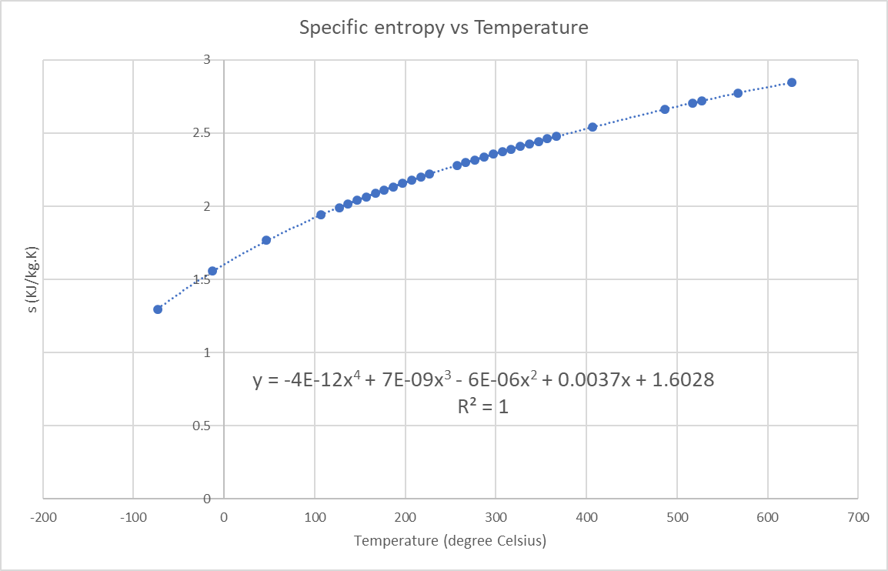

Figure 2

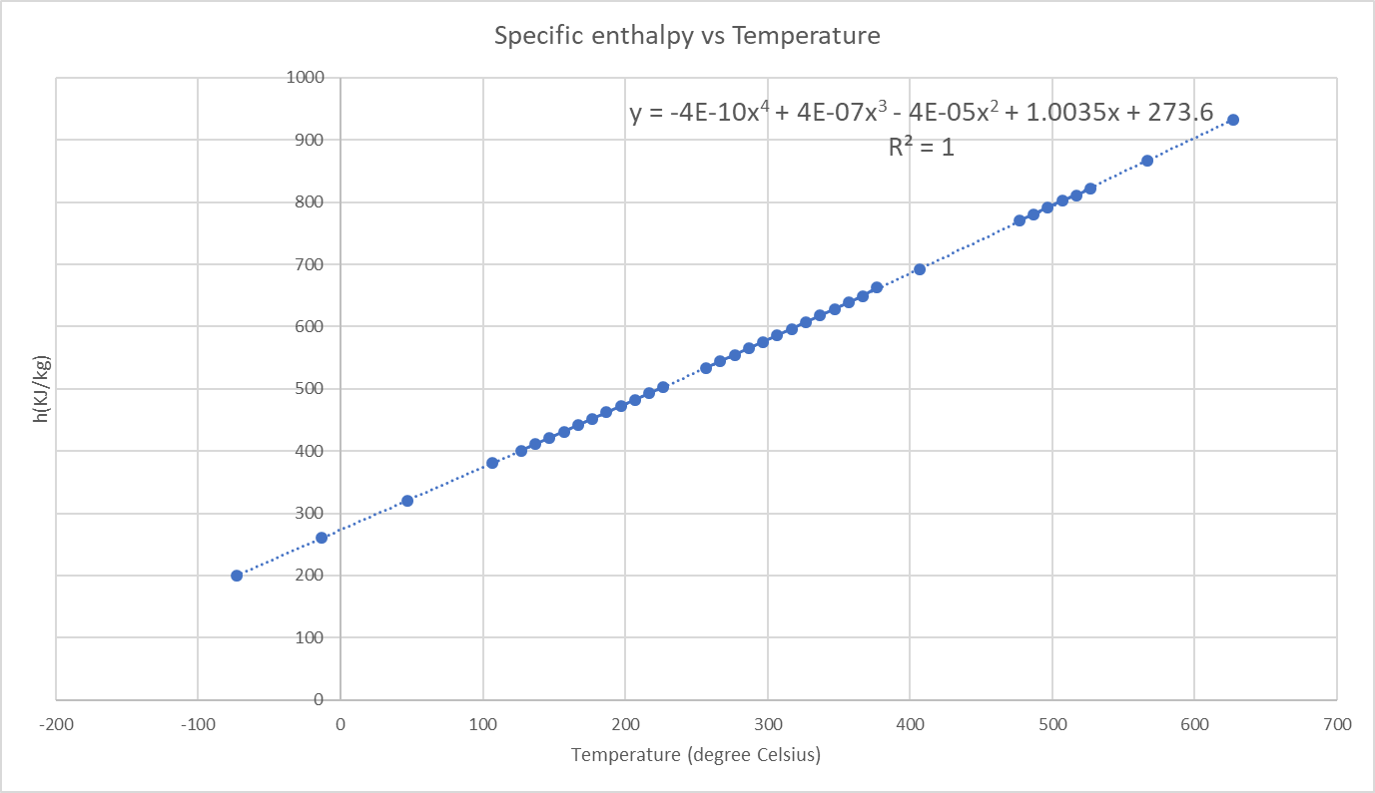

Figure 3

**Results**

**Case 1**

For this case, the pressure at inlet and outlet for air are the same at 200 kPa. By using equation 9, we can use both fixed end cases one at a time to calculate the exergy per mass flow rate of water. First is by fixing the inlet temperature of air at 400 degree Celsius and then varying temperature of the outlet. Repeat vice versa for fixed outlet where the inlet is varying in temperature. The results after applying both fixed end cases are shown below.

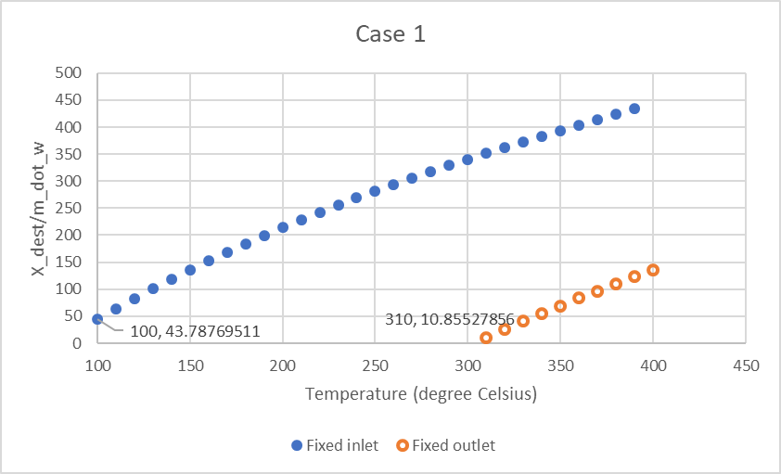

Figure 4

Based from the plot above, the filled line indicates the fixed inlet at T = 400 degree Celsius while the non-fill line refers to the fixed outlet at T = 150 degree Celsius. Before diving into the plot, we need to understand the correlation between exergy destroyed and the temperature difference. Referring to equation 9, if we increase the air temperature difference, the destroyed exergy per mass flow rate of water will increase. From here onwards destroyed exergy per mass flow rate of water is denoted by X_m.

Now let us look at the slope for the filled line which shows the fixed inlet. When looking at the filled curve, it shows the X_m against the temperature range at the outlet. Thus, we can read the x-axis as the temperature at the outlet. From this filled curve, it indicate that as the temperature of the outlet increases, X_m will increase.

Similarly for the fixed outlet, it shows the same pattern where X_m increases as temperature of inlet increases. For both fixed end cases, the positive destroyed exergy per mass flow rate of water should be focused on instead of negative value of destroyed exergy since it does not make sense and impossible to have a negative value of destroyed exergy.

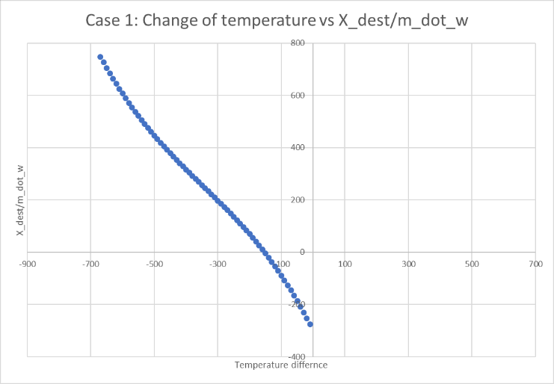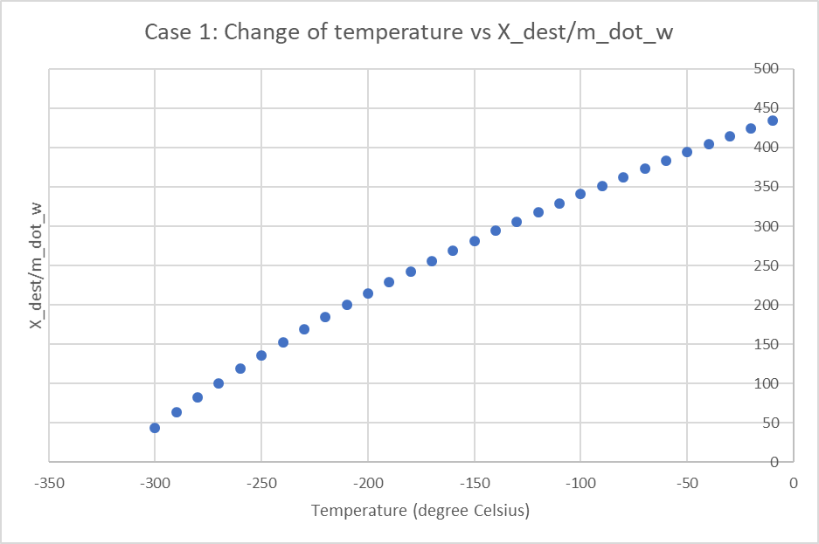

Figure 5: Fixed inlet at 400 degree Celsius (left), fixed outlet at 150 degree Celsius (right)

Other than looking at the trend of the curves, one need to confirm if it matches with the correlation between exergy destroyed and the temperature difference. Thus plots of temperature change (Outlet temperature - inlet temperature) against X_m is created at figure 5. Referring to figure 5, the plot on the left does not validates the correlation concept while the plot on the right matches with the concept. This could be caused by error from setting up equation on Excel.

The result for case 1 where it produces the minimum X_m, the maximum temperature of the inlet can be 310 degree Celsius (for fixed outlet) and the minimum temperature at the outlet is 100 degree Celsius (for fixed inlet). Comparing both fixed end cases results, the minimum X_m is 10.9 kW/kg when the outlet is fixed at 150 degree Celsius and the inlet temperature is 310 degree Celsius.

**Case 2**

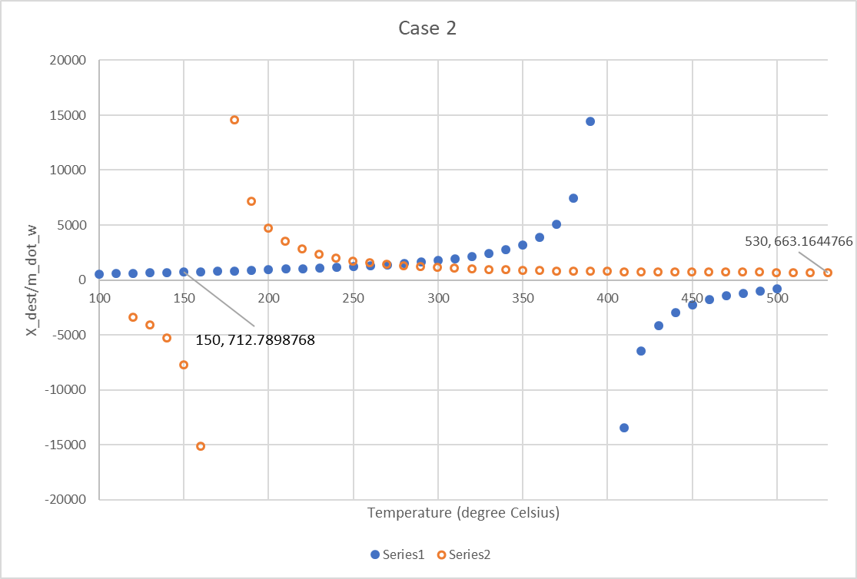In this case, the pressure at inlet and outlet for air are different where the inlet pressure is at 200 kPa while the outlet pressure is 100kPa. By using equation 8, we can repeat the process used in case 1. The results after applying both fixed end cases are shown below.

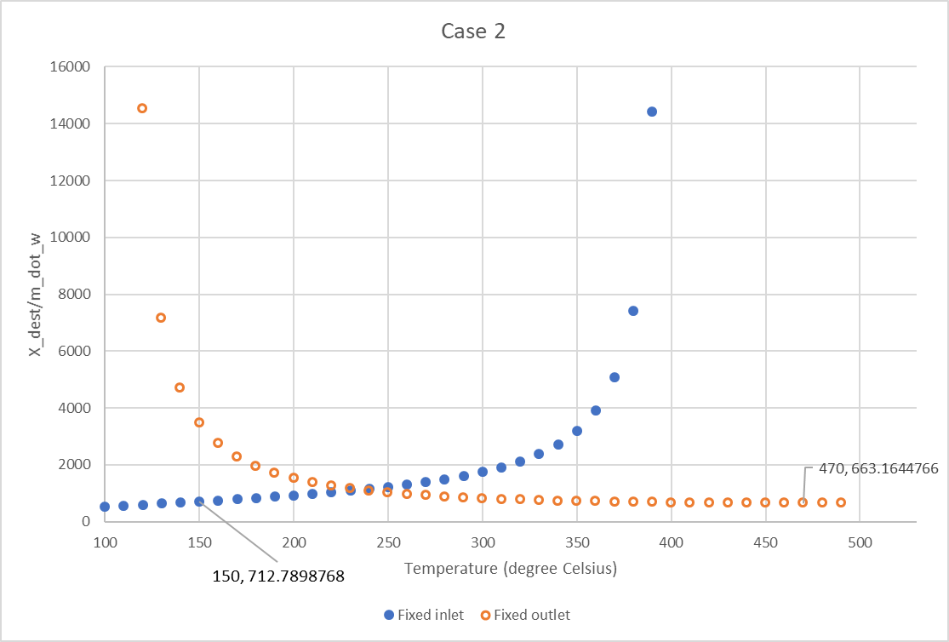

Figure 6

Figure 7

Based from the plot above, again the filled line indicates the fixed inlet at T = 400 degree Celsius while the non-filled line refers to the fixed outlet at T = 150 degree Celsius. In figure 6, it shows that X_m goes to infinity at 150 degree Celsius and 400 degree Celsius. The reason is because of the way equation 8 was set up where it now considers the pressure difference and our initial boundary condition at inlet ant outlet. By excluding negative values of X_m, the figure 7 where it only focuses on the positive values of X_m.

From figure 7, the filled curve shows the same trend as in case 1 but the non-filled curve shows the opposite. If we look at the fixed inlet, the minimum destroyed exergy per mass flow rate of water is when the temperature at the outlet is around 100 degree Celsius. While if we fix the outlet, the minimum destroyed exergy per mass flow rate of water is when the temperature at the inlet is around 510 degree Celsius. The intersection shows the produced destroyed exergy per mass flow rate of water exist in both cases. Thus the same X_m is produced when either the outlet temperature is 270 degree Celsius when the inlet is fixed at 400 degree Celsius or when the temperature at the inlet is 270 degree Celsius when the outlet is fixed at 150 degree Celsius.

In addition to the information given, one can validate how the results matches with the correlation of exergy destroyed and temperature difference. Those inquiry can be referred to the figure below after excluding negative X_m values. The first plot on the left shows the opposite from our expected correlation while the right side shows partially correct. On the right figure, it shows a negative trendline as the temperature difference gets smaller and after reaching temperature difference of -300 degree Celsius, it shoots up. Again, this could be from the equation set up error in Excel.

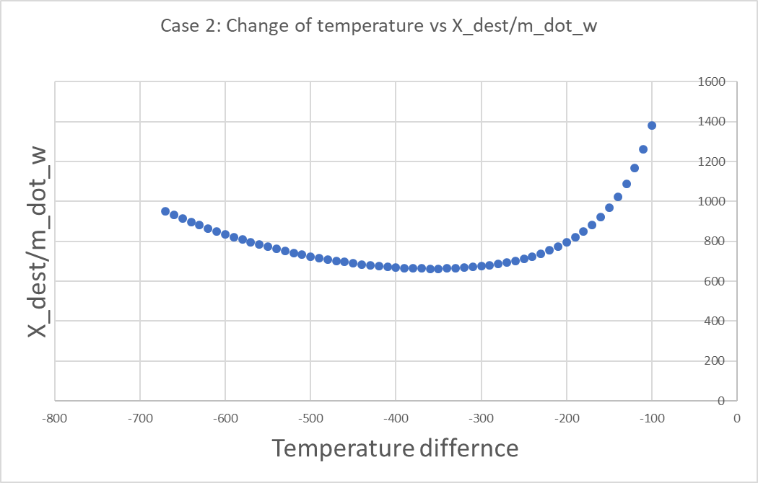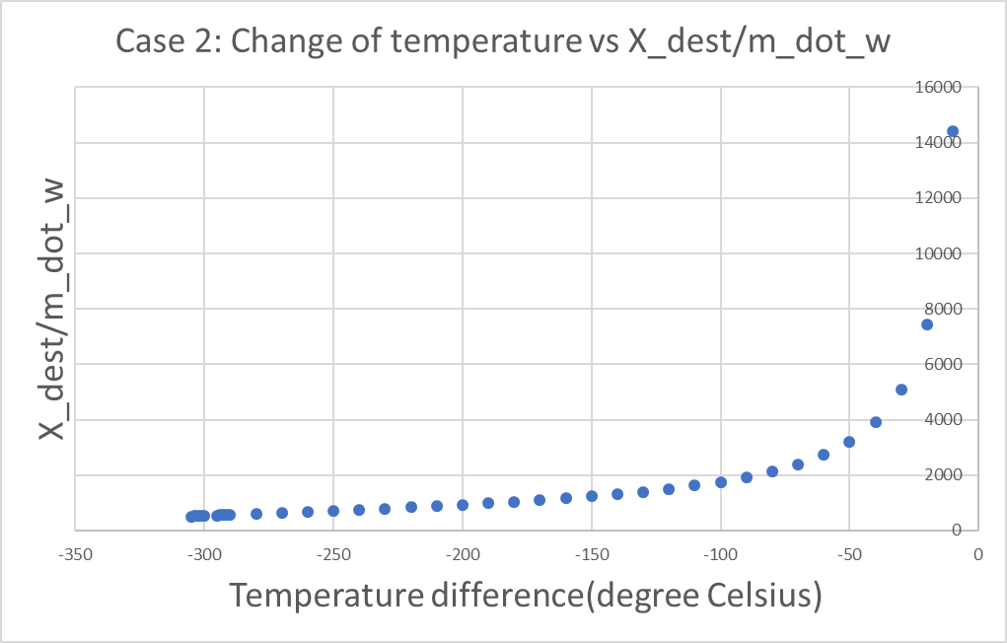

Figure 8: Fixed inlet at 400 degree Celsius (left), fixed outlet at 150 degree Celsius (right)

The result for case 2 stipulate that the minimum X_m is produced when the maximum temperature of the inlet can be 510 degree Celsius (for fixed outlet) and the minimum temperature at the outlet is 100 degree Celsius (for fixed inlet). Comparing both fixed end cases results, the minimum X_m is 527 kW/kg when the inlet is fixed at 400 degree Celsius.

**Conclusion**

From our results, we found that the inlet temperature for case 1 is 310 degree Celsius while for case 2, the inlet temperature is 400 degree Celsius. There are several factors that we can point out. First, when the pressure at the outlet is lower than the pressure at the inlet, it produced a higher exergy destroyed. Second, when the temperature difference between inlet and outlet increases, the exergy destroyed will also increase. To improve that the results we obtained can be valid, we can recheck our equation set up on Excel. Another way to approach is by making the estimation of the mass flow rate of water and air. Since the specific heat capacity of water is four times of the specific heat capacity of air, therefore the mass flow rate of water is about four times the mass flow rate of air. Then one can repeat the procedure by calculating the exergy destroyed per mass flow rate of water and then compare with our results in this report.

**References**

1. MORAN, MICHAEL J. FUNDAMENTALS OF ENGINEERING THERMODYNAMICS. JOHN WILEY &amp; SONS, 1988.
2. “STP - Standard Temperature and Pressure &amp; NTP - Normal Temperature and Pressure.” Engineering ToolBox, www.engineeringtoolbox.com/stp-standard-ntp-normal-air-d_772.html.